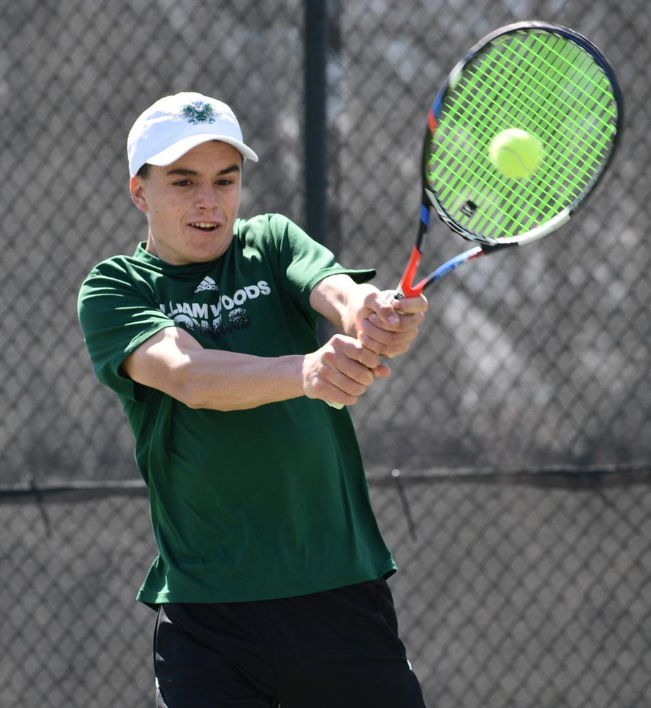



SPORTS ENRICHMENT PROGRAM
APPLICATION FORM 2023
Ben Grumley
Former Lavalla Catholic College student
Current attends the William Woods University

To qualify for this program you must be playing at an academy or equivalent level ( year 7 – 10) and at a State level (year 11- 12) and training at least 10 hours a week.
STUDENT INFORMATION
First Name:
Surname:
Date of Birth:
Age (now):
Year Level in 2023:
LA in 2022:

STUDENT ATHLETE PROFILE
Sport(s):
Current Level:
(National, State, Academy, Squad)

CURRENT CLUBS / TEAMS
Local / Domestic Level:
“A” Grade, U14’s, etc.
Representative Level:
Squad, Interleague
State/National Level:
State swimming time, State team selection
Playing Position:
Coach(s):

STUDENT ATHLETE PROFILE

NORMAL WEEKLY TRAINING / COMPETITION SCHEDULE
Sample:
 | Monday | Tuesday | Wednesday | Thursday | Friday | Saturday | Sunday
AM  Location |  |  |  |  |  |  | TDJFL  Football  9:00am - 11:00am  Traralgon
PM  Location | Squad b’ball  Training  5:00pm - 6:30pm  Traralgon | Football  Training  4:30pm - 5:30pm  Traralgon | Domestic  B’ball training  5:00pm -  6:00pm  Traralgon  Domestic  Basketball  5:00pm -  6:00pm  Traralgon | Football  Training  4:30pm - 5:30pm  Traralgon  BVC  Academy  6:00pm - 7:00pm  Traralgon | VJBL  Basketball  5:00pm - 11:00pm  Traralgon/  Melbourne |  | Basketball  Training  3:30pm - 5:00pm  Traralgon  Squad b’ball  Training  6:00pm - 7:30pm  Traralgon

 | Monday | Tuesday | Wednesday | Thursday | Friday | Saturday | Sunday
AM

Location

PM

Location

Total time spent training/playing per week:

Total time spent travelling per week:

STUDENT ATHLETE PROFILE

SPORTING GOALS
Indicate briefly what the athlete is aspiring to achieve as future sporting goals.
Short term: (Next 1-2 years)
Sample short term goal: To be identified and gain selection to Gippsland Power Academy

Medium term: (Next 3-4 years)
Sample medium term goal: Make the Gippsland Power squad

Long term: (Next 5-10 years)
Sample long term goal: Be drafted into the AFL

HOW COULD THE SPORTS ENRICHMENT PROGRAM ASSIST YOU WITH YOUR SPORTING ASPIRATIONS?

INDIVIDUAL ACHIEVEMENTS
Indicate what accolades you have received in the past year/season. Include event, date, team or individual awards or other levels of performance.

COACHES FEEDBACK (OPTIONAL). Attach any extra information.

